**Bronze Deer Head Wall Mount**

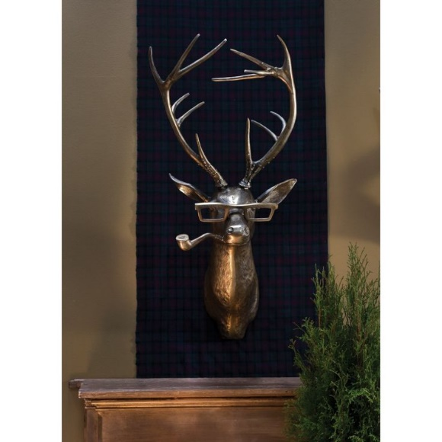The Bronze Deer Head Wall Mount is a sophisticated and bold decor piece that brings the natural world into your home with an elegant twist. Crafted in a rich bronze finish, the deer head exudes a timeless, vintage appeal while adding texture and depth to any room. Its realistic design, with intricate detailing in the antlers and facial features, enhances the overall aesthetic, making it a standout focal point. This wall mount is perfect for rustic, industrial, or eclectic interiors, offering a striking blend of nature-inspired beauty and refined luxury.